Project Design Phase-II Technology Stack (Architecture & Stack)

|  |  |
| --- | --- |
| Date | 15 October 2022 |
| Team ID | PNT2022TMID08854 |
| Project Name | Demand Est_ AL Powered Food Demand Forecaster |
| Maximum Marks | 4 Marks |

Technical Architecture:

The Deliverable shall include the architectural diagram as below and the information as per the table1 & table 2

Example: Order processing during pandemics for offline mode

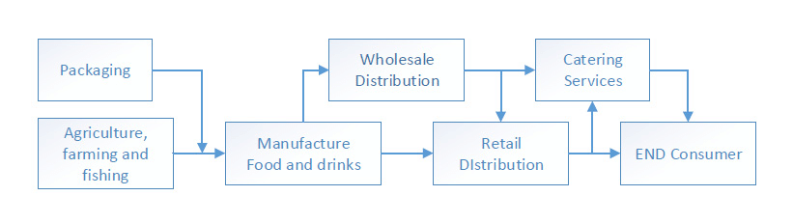

Table-1 : Components & Technologies:

|  |  |  |  |
| --- | --- | --- | --- |
| **S.No** | **Component** | **Description** | **Technology** |
| 1. | Customer | Producing the desired output | HTML, CSS, bootstrap . |
| 2. | Restaurent | It includes all the goods and services that the food components of the restaurent meals. | Online transactions(Food delivery) |
| 3. | Geolocation | Used to reach the current location. | Google map, Geo Location. |
| 4. | Platform owner | Wait for the delivery of the food items. | Mobile phones and online websites. |
| 5. | Database Analytics | Data Type, Configurations etc. | MySQL, MongoDB, etc. |
| 6. | Cloud Database | Database Service on Cloud | IBM DB2, IBM Cloudset etc. |
| 7. | File Storage | User data information. | IBM cloud Storage or Other Storage Service or Local Filesystem |
| 8. | Amazon s3 bucket | Storage with data set access availability. | HTTP interference using interface . |
| 9. | Competitive conditions | Purpose of External API used in the application | Notification services and ensure stability |

Table-2: Application Characteristics:

|  |  |  |  |
| --- | --- | --- | --- |
| **S.No** | **Characteristics** | **Description** | **Technology** |
| 1. | Open-Source Frameworks | Microsoft edge, online websites | Technology of Opensource tools |
| 2. | Security Implementations | Authentications through OTP. | Through mobile phones. |
| 3. | Scalable Architecture | Based on quality. Based on taste. | Quality assurance Quality control. |
| 4. | Availability | Available through online mode | Online system analysis |
| 5. | Performance | Provide qualitative food  Encourage customer loyalty. Boost sales. | Choice of method and test accuracy |